Date of publication xxxx 00, 0000, date of current version xxxx 00, 0000.
Digital Object Identifier 10.1109/ACCESS.2024.Doi Number
Design and Simulation of a Broadband Tunable Transmittance Optical Filter Using Sb₂Se₃ Phase Change Material
CHETTANAT PADUNGATTHAKIJ¹, SURAWUT WICHARN^{2,*}, (Member, IEEE),
SUEBTARKUL SUCHAT³, AND PRATHAN BURANASIRI^{1,4}
¹Artificial Intelligence Photonics Advanced Research Laboratory, Department of Physics, School of Science, King Mongkut’s Institute of Technology Ladkrabang, Bangkok 10520 Thailand
²Department of Physics, Faculty of Science, Srinakharinwirot University, Bangkok 10110 Thailand
³Department of Physics, Faculty of Science and Technology, Phranakhon Rajabhat University, Bangkok 10220 Thailand
⁴Electronic and Optoelectronic Device Research Unit, School of Science, King Mongkut’s Institute of Technology Ladkrabang, Bangkok 10520 Thailand
Corresponding author: Surawut Wicharn (surawutw@g.swu.ac.th).
This work was supported in part by the funding from School of Science, KMITL (CN-1-2568-010).
ABSTRACT We propose a switchable transmittance filter that operates around 1064 nm wavelengths using antimony triselenide (Sb₂Se₃). Sb₂Se₃ is a phase change material (PCM) that has low absorption in the infrared (IR) spectrum, large and stable refractive index contrast between the two phases, and high optical endurance of ~10⁶ cycles. We provide the reasoning for selecting a long-pass edge-filter design and compare its performance to other planar thin-film designs. At 1064-nm, the selected 5-unit-cell edge-filter design has 93.6% transmittance in amorphous phase and 0.2% in crystalline phase, a 93.4% transmittance contrast with ~200 nm FWHM. It has minimal transmittance degradation after enduring over 1.5×10⁶ phase switching cycles. We show the transmittance tunability of the design by changing the phase of each Sb₂Se₃ layer, and each layer thickness can be optimized to increase the optical performance across the 900-1200 nm wavelengths.
INDEX TERMS Antimony triselenide, Optical designs, Optical filters, Phase change materials, Thin films
- INTRODUCTION
The term phase change material (PCM) can have different meanings depending on the research field. In energy storage, the term refers to materials that can store and release its thermal energy though changes in its state of matter, e.g. from solid to liquid state [1]. However, in the fields of electronics and photonics, the term refers to a solid-state material that changes its crystal structure when depending on the temperature, such as from amorphous to crystalline phase when temperature rise above transition temperature (T_{trans}). This change leads to a high contrast in complex refractive index ñ between the initial and post-transitioned phases, where ñ = n + ik comprises of the real refractive index n and the imaginary extinction coefficient k [2]. The refractive index contrast is an order of magnitude larger than the contrast from applied electric field or Kerr effect (light intensity) [3], this property makes PCMs ideal for photonic applications that require the modulation of optical performance. Some examples are reconfigurable metasurfaces [2, 4-6], optical limiters [3, 7-11], optical switches [12, 13], optical filters [14-17], and absorbers [18, 19].
The classification of PCM can be done by its behaviour post phase transition. It is considered a volatile PCM if the phase reverts back to pre-transition phase when the temperature falls below T_{trans}. It is considered a non-volatile PCM if it maintains its post-transition phase when temperature falls below T_{trans}, a way to changes the phase back to pre-transition is to melt and then rapidly quench to a temperature below T_{trans}. The quenching speed needs to be fast enough such that the atoms do not have time to form orderly bonds. One of the most common volatile PCM is vanadium dioxide (VO₂), it undergoes metal-to-insulation transition (MIT) at 68 °C, the lowest among any PCMs. VO₂ has a relatively large complex refractive index contrast (Δn) in the near-IR and IR spectra [20], but its biggest downside is the large absorption due to high extinction coefficients in both phases, this limits the maximum thickness a design can have before the absorption is too high for efficient devices. A common non-volatile PCMs are chalcogenide glasses called Ge₂Sb₂Te₅ (GST) and Ge₂Sb₂Se₄Te (GSST). GST beings one of the earliest and most studied PCM [21], it has large refractive index contrast between amorphous and crystalline phases, relative low T_{trans} at ~145 °C when compared to other PCMs [3, 22]. Meanwhile GSST, which is a derivative of GST that substitutes parts of tellurium (Te) with selenium (Se), has lower extinction coefficients than either GST or VO₂. But when compared to GST, it has higher T_{trans} at ~242 °C, and the Δn is also lower [22].
With that being said, antimony triselenide (Sb₂Se₃) is a non-volatile PCM which originated from solar-energy applications, but it has very few research in the field of photonics. Sb₂Se₃ unique properties are it near-zero extinction coefficients in near IR and IR spectra, its high and stable refractive index contrast, and very high phase switching endurance in an order of 10⁶—10⁷ cycles [23, 24]. It transition temperature is in between GST and GSST, at ~186 °C [23, 25]. These properties make Sb₂Se₃ an attractive PCM for low-loss, reconfigurable devices used as optical switches or programmable circuits in optical waveguides [4-6, 13, 15, 21]. But its usage as a tunable transmittance filters has not been explored much [16].
The transmittance of an optical filter can be modulated by the changes in refractive index of PCM. The ON mode has high transmission by creating antireflection condition and minimizing the absorption from the filter, and OFF mode has low transmission after phase transition. The method for switching Sb₂Se₃ phase could be from laser-induced heating [23], or from electrical heating [14]. The switching via laser heating cannot be from infrared light since Sb₂Se₃ has very small absorption at that wavelengths. The architecture can be multilayer planar thin-film structures or nanostructure metasurfaces; planar structures are more straightforward to design and fabricate, while metasurfaces offer higher design flexibility [10]. For planar designs, there are many methods for creating antireflection condition, such as single-layer or multilayer antireflection designs, line-pass filters, or Fabry–Pérot resonant cavities [17, 26].
In this work, we investigate Sb₂Se₃ as a PCM in planar thin-film designs for transmittance tunable optical filters. The operating wavelength is selected to be 1064 nm, Nd:YAG laser wavelength which is commonly used in laboratory setups. At this wavelength, Sb₂Se₃ exhibits zero absorption in the amorphous phase and near-zero absorption in the crystalline phase, and its refractive index contrast is high and stable throughout the IR spectrum. The goal is to create a low-loss, broadband transmittance-tunable optical filter.
THEORIES
- OPTICAL PROPERTIES OF ANTIMONY TRISELENIDE
Antimony triselenide (Sb₂Se₃) is an orthorhombic chalcogenide non-volatile phase change material (PCM) characterized by quasi-one-dimensional ribbons. While its amorphous phase consists of a disordered network of distorted motifs, crystallization restores long-range order along the ribbon direction. This thermally driven transition can be triggered by nanosecond to microsecond optical or electrical pulses [21, 23]. The process is reversible and has high endurance, with optical switching reaching 10⁶ to 10⁷ cycles [23, 24]. As an optical device, Sb₂Se₃ enables repeatable toggling between high and low transmission modes, provided that local heating remains below the melting or ablation threshold [4, 24].
The complex refractive index ñ of any phase change material at wavelength λ is:
${\tilde{n}}_{p}\left(λ\right)=n_{p}\left(λ\right)+ik_{p}\left(λ\right)$ (1)
where p denotes the phase of Sb₂Se₃ which can be either amorphous (amo) or crystalline (cry) phase. Dispersive models, such as Tauc-Lorentz or multi-oscillator fits are often used to represent the measured n_{p} and k_{p} over the spectral range of interest. However, in this work, linear interpolation is used because all the datasets used have measurement interval of less than 4 nm. Figure 1 shows their complex refractive indices from 300 to 1700 nm using the dataset from Delaney, et al. [21], where the complex refractive indices at 1064 nm are ñ_{amo} = 3.370 + 0.000i and ñ_{cry} = 4.308 + 0.010i. The blue lines represent real refractive index (n) and the red lines represent imaginary extinction coefficient (k). In amorphous phase, the refractive index increases from ~2.4 at 300 nm to a peak of ~4.0 at 600 nm and gradually decreases to a stable value of ~3.3 above 1200 nm, indicating a strong dispersion near the band edge of visible spectrum and a weaker dispersion in the NIR spectrum. The extinction coefficient starts from ~2.1 at 300 nm and drops to zero at ~850 nm. In the crystalline phase, the refractive index at the UV wavelengths is around the same value as the amorphous phase but reaches a higher peak of ~5.1 at around 660 nm; it then drops to a stable value of ~4.1 in the NIR spectrum. The absorption index of crystalline phase peaks at ~3.1 in the near-UV spectrum and rapidly approaches zero above 900 nm.
The refractive index contrasts (Δn = n_{c} - n_{a}) are large and stable from the visible through IR spectra, and the extinction coefficients are large in the near-UV region but fall to zero around the NIR spectrum for both phases, with the crystalline phase exhibiting higher absorption in the visible spectrum. Thus, when compared to other PCMs, Sb₂Se₃ has several advantages when operating in the NIR and IR wavelengths. The large Δn and low k starting from NIR wavelengths enable a device to operate in two modes with little to no optical loss, and a stable Δn also helps with broadband designs.
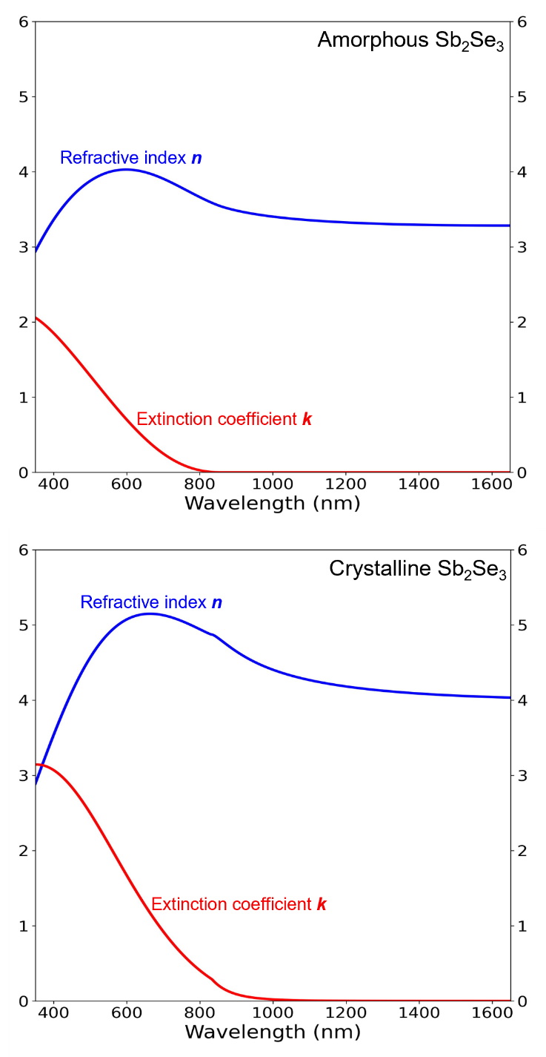
Complex refractive index of Sb₂Se₃. Graphs are plotted from experimental data of [21].
- SINGLE-LAYER ANTIREFLECTION DESIGN
The goal of designing most optical devices is to either create antireflection or high-reflection conditions. For a two-mode optical device, such as a transmittance tunable filter, we can consider the reflection in the ON mode first, and then the reflectance contrast ΔR between the ON and OFF modes. The simplest antireflection from a planar thin-film design is one film layer deposited on top of a substrate; both the film and the substrate should have zero absorption. The diagram in the top right corner of Fig. 2 shows that a single-layer film reflects light at two interfaces: the bottom interface between the film and substrate (R₁) and the top interface between the air and film (R₂). Antireflection occurs from the destructive interference between R₁ and R₂, with a complete AR condition requiring the same amplitude and a phase difference of π radian (optical path length of λ/2). Because R₁ propagates through the thin film layer twice (while transmitted down and reflected backup), the optical thickness (OT) of the film only needs to be equal to half of the optical path length, OT = λ/4, this also known as quarter-wave optical thickness (QWOT). The optical thickness is related to the physical thickness t by the following equation:
$OT(λ)=n(λ) t$, (2)
where n(λ) is the refractive index of the film at λ. For a single-layer AR device, the thin-film physical thickness t must be
$t=\frac{OT}{n}=\frac{λ/4}{n}$. (3)
Another method for calculating the thickness required for the AR condition is to consider the reflection of the device. The reflectance R of only the substrate is related to the Fresnel coefficient r by
$R= {\left|r\right|}^{2}={\left|\frac{n_{a}-n_{s}}{n_{a}+n_{s}}\right|}^{2}$, (4)
where n_{a} is the air refractive index, and n_{s} is the refractive index of substrate. If a single-layer film is placed on top of a substrate, the film and substrate layers can be combined into an effective reflectance index n_{r} [26], defined as
$n_{r}=n_{f}\frac{\left(n_{s}+n_{f}\right)+\left(n_{s}-n_{f}\right)e^{-i2θ}}{\left(n_{s}+n_{f}\right)-\left(n_{s}-n_{f}\right)e^{-i2θ}}$, (5)
where n_{f} is the film refractive index, i is the imaginary unit, and θ is the phase thickness which is related to optical thickness and physical thickness t by the angular wavenumber k₀ = 2π/λ:
$θ=k_{0}OT=k_{0}nt$. (6)
By replacing n_{s} in Eq. 4 with n_{r} from Eq. 5, the reflectance of a single-layer device becomes:
$R={{\left|r\right|}^{2}=\left|\frac{n_{a}-n_{r}}{n_{a}+n_{r}}\right|}^{2}$. (7)
The antireflection condition happens when R = 0 or n_{r} = n_{a}. This condition occurs when the phase thickness θ is in multiple of π/2 radians:
$θ=Z\frac{π}{2}$, (8)
where Z denotes even integer. If this condition is satisfied, Eq. 5 can be simplified with Euler’s identity (exp^{-iπ} = -1) to:
$n_{r}=n_{f}\frac{\left(n_{s}+n_{f}\right)-\left(n_{s}-n_{f}\right)}{\left(n_{s}+n_{f}\right)+\left(n_{s}-n_{f}\right)}=\frac{n_{f}^{2}}{n_{s}}$. (9)
By substituting this into Eq. 7, the refractive indices for antireflection condition becomes:
$n_{a}n_{s}=n_{f}^{2}$ (10)

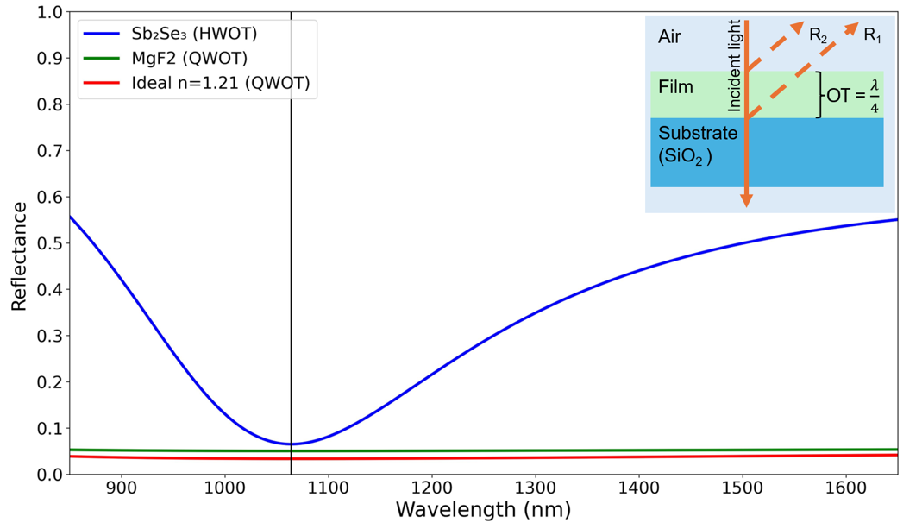
The reflectance of a single-layer design with different refractive index and thickness, the black vertical line indicates 1064 nm. At this wavelength, HWOT-thick Sb₂Se₃ (blue) has the highest reflection R = 6.5%. QWOT-thick MgF₂ (green) R = 5.0%. An ideal QWOT-thick film with n_{ideal} = 1.21 (red) has the lowest reflectance, R = 3.4%. Cross-section diagram of the QWOT-thick structure is shown in the top-right corner.

Another condition is the relative refractive index between the air, film, and substrate, which must be in the following order: n_{air} < n_{f} < n_{substrate}. Light shifts its phase by π radian when reflected from a lower to a higher refractive index medium. The reflected light at the air-film interface (R₂) will always undergo a π radian phase shift since n_{a} will be the lowest in most cases. Therefore, R₁ must undergo the same phase shift to create destructive interference.
These two conditions limit material selections for a perfect antireflection, since there is only one ideal refractive index (n_{ideal}) for each n_{s}. The refractive index of Sb₂Se₃ is higher than that of substrate (silica; SiO₂) at every wavelength. So, if Sb₂Se₃ is QWOT, the reflection from R₁ still travels 2QWOT (π radian) further than R₂ but only R₂ has its phase shifted by π radian during reflection, so the two R’s have a phase difference of 0 radian, a constructive interference. To minimize reflection, the Sb₂Se₃ thickness can be increased to twice the QWOT (OT = λ/2), this is called half-wave optical thickness (HWOT) and is equivalent to an absentee layer. For example, at the reference wavelength λ₀ = 1064 nm, if we use 3-mm-thick SiO₂ as the substrate (n_{s} = 1.46) [27], the ideal QWOT-film thickness is calculated from Eq.10 to be n_{ideal} = 1.21. The material with the closest refractive index is MgF₂ (n_{MgF2} = 1.38) [28]. A slight difference from ideal value causes the reflection to be slightly higher, as illustrated in Fig. 2. The reflectance of the Sb₂Se₃ (blue) is the highest, at 6.5%, because the PCM layer is an absentee layer, so the reflection is equivalent to a standalone 3-mm SiO₂ substrate. An ideal film (red) still exhibits small reflectance because of the reflection in the substrate-air layer in the back.
- MULTILAYER ANTIREFLECTION DESIGN
Two-layer design with each layer thickness being QWOT (Q/Q design) is also be used to create antireflection conditions. The Fresnel reflection coefficient r from Eq. 7 can be expanded to
$r=\frac{n_{a}-n_{r2}}{n_{a}+n_{r2}}=\frac{n_{a}-(\frac{n_{f2}^{2}}{n_{r1}})}{n_{a}+(\frac{n_{f2}^{2}}{n_{r1}})}=\frac{n_{a}-(\frac{n_{f2}^{2}}{n_{f1}^{2}/n_{s}})}{n_{a}+(\frac{n_{f2}^{2}}{n_{f1}^{2}/n_{s}})}$, (11)
where n_{f} begins from the substrate side and increases toward the air side (n_{s} / n_{f1} / n_{f2} / n_{a}), n_{r2} is the effective reflectance index of the entire structure [26], and n_{r1} is the effective reflectance index of only the substrate (n_{s}) and bottom film (n_{f1}). Similar to Eq. 7, the antireflection condition of the two-layer design occurs when n_{a} = n_{r2} or
$n_{a}=\frac{n_{f2}^{2}}{n_{f1}^{2}/n_{s}}$, (12)
$\frac{n_{a}}{n_{s}}=\frac{n_{f2}^{2}}{n_{f1}^{2}}$. (13)

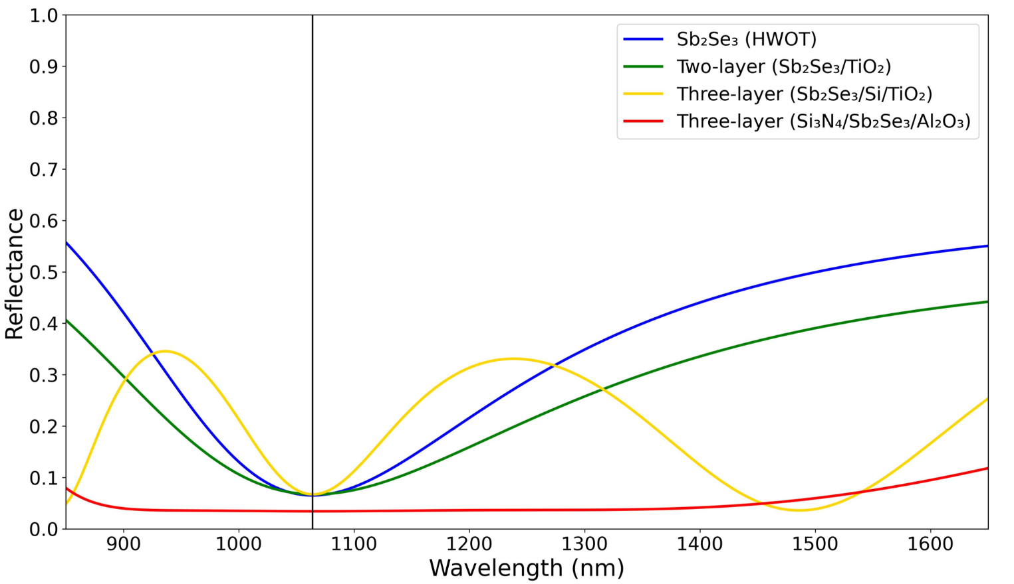
The reflectance profiles of four different designs. The single-layer, two-layer, and three-layer design with Sb₂Se₃ at the bottom have around the R = 6.5–6.7%. However, the three-layer design with Sb₂Se₃ as middle layer has refractive index ratio of n_{f1} and n_{f2} closer to ideal values, so its reflectance value is the lowest at R = 3.4%.

From Eq. 13, it can be seen that the refractive index of the top film must be smaller than the bottom film (n_{f2} < n_{f1}). For example, at λ₀ = 1064 nm, if we use the same SiO₂ substrate (n_{s} = 1.46) and Sb₂Se₃ as the bottom film (n_{f1} = 3.37), the ideal refractive index of the top film (n_{f2}) is 2.78. A commonly used material with the closest refractive index is TiO₂ (n_{TiO2} = 2.31) [29]. Compared to the single-layer Sb₂Se₃ design, the two-layer Sb₂Se₃/TiO₂ design has a lower reflectance at 1064 nm and wider AR region, as shown in Fig. 3. Another way to create a two-layer AR condition is to fix the two film refractive indices and vary the thickness of each film, as explained in Chapter 5.2 of [26]. However, this method narrows the spectral range of the antireflection region.
A three-layer design with an HWOT-thick film in the middle (Q/H/Q) requires refractive index orderings of n_{s} < n_{f1} < n_{f2} and n_{f2} > n_{f3} > n_{a} for antireflection properties. The middle layer (n_{f2}) acts as an absentee layer when the incident wavelength is the same as the reference wavelength (λ = λ₀). The reflection coefficient is equal to
$r=\frac{n_{a}-n_{r3}}{n_{a}+n_{r3}}=\frac{n_{a}-\left(\frac{n_{f3}^{2}}{n_{r2}}\right)}{n_{a}+\left(\frac{n_{f3}^{2}}{n_{r2}}\right)}$. (14)
Because the middle film layer (n_{f2}) is HWOT thick, it behaves as an absentee layer [26, 30]. So n_{r2} = n_{r1}, and Eq. 14 becomes:
$r=\frac{n_{a}-\left(\frac{n_{f3}^{2}}{n_{r1}}\right)}{n_{a}+\left(\frac{n_{f3}^{2}}{n_{r1}}\right)}=\frac{n_{a}-\left(\frac{n_{f3}^{2}}{n_{f1}^{2}/n_{s}}\right)}{n_{a}+\left(\frac{n_{f3}^{2}}{n_{f1}^{2}/n_{s}}\right)}$, (15)
and a three-layer antireflection condition occurs when
$\frac{n_{a}}{n_{s}}=\frac{n_{f3}^{2}}{n_{f1}^{2}}$. (16)
The refractive index ratio of top and bottom films is similar to that of the two-layer design. As an example, if the bottom layer (n_{f1}) is Sb₂Se₃ (QWOT), then the ideal top layer (n_{f3, ideal}) is 2.78, so TiO₂ (n_{TiO2} = 2.31) is used again. The middle layer needs to have the highest refractive index, so Silicon (Si) is used (n_{Si} = n_{f2} = 3.55) [31]. As shown in Fig. 3, the reflectance of the three-layer design (yellow) at wavelengths further from λ₀ (i.e., 1400 nm and longer) is lower than that of a single (blue) or two-layer design (green). This is a benefit of adding an extra absentee layer in the middle, it contributes to a broader operating bandwidth [30].
Instead of placing the PCM as the bottom film layer, Sb₂Se₃ can be moved to the middle so that the selection of ideals n_{f1} and n_{f3} is easier. The bottom layer could be Si₃N₄ (n_{f1} = 2.00) [32] and the ideal top layer calculated using Eq. 16 has n_{f3} = 1.65, which Al₂O₃ has the closest refractive index (n_{Al2O3} = 1.62) [29]. These designs are shown in Fig. 3, where the reflectance of the designs with Sb₂Se₃ deposited directly on top of the substrate, i.e., single-layer, two-layer, and three-layer designs, are ~6.5%. But the three-layer design with Sb₂Se₃ placed in the middle (n_{f2} = Sb₂Se₃) has a reflectance of 3.4%, which is the same value as that of an ideal single-layer design (3.4%). This improvement can be explained by the selection of n_{f1} and n_{f3} which are closer to ideal values.
- LONG-PASS EDGE-FILTER DESIGN
In previous sections, we only consider the reflectance of the design when Sb₂Se₃ is in amorphous phase (ON mode). However, because we want to modulate the performance of our optical filters, the reflectance when Sb₂Se₃ transition to crystalline phase (OFF mode) should also be considered. A high reflectance contrast between crystalline and amorphous phases (ΔR = R_{c} – R_{a}) indicates a good modulation power. The reflectance plots of the four designs from Fig. 3 are shown in Fig. 4. The single-layer design reflectance profile red-shifted for ~250 nm and is the only one that has reflectance contrast higher than 50% (Fig 4a, blue: ΔR=55%). More importantly, the three-layer design with Sb₂Se₃ in the middle, which has the lowest reflectance in amorphous phase (R_{a} = 3.4%), only has R_{c} = 14.8% (Fig 4b, red: ΔR=11.4%).
So, we need a new structure that has high reflectance contrast but still maintain low reflection in amorphous phase. This introduces us to edge-filter design, the reflectance profile has HR-region centered around the reference wavelength, while the regions outside of this are both AR regions, with a steep spectral edges between the AR- and HR-regions. Edge filter consists of QWOT-thick high-index film (H) and low-index film (L) deposited on top of each other in a structure called unit cell (U), it can either be a long-pass $\left(H/2 L H/2\right)$ or a short-pass designs $\left(L/2 H L/2\right)$ the 1/2 symbol denotes half QWOT thickness (OT = λ⁄8). The spectral width of HR-region is directly correlated to the difference between H and L layer, and the number of unit cell directly correlated to the steepness of spectral edge between region. The long-pass design has stable, low reflectance in the longer-wavelength AR region, while short-pass design has the opposite behavior. The long-pass design is selected for this work since it minimize the device thickness. And since we want our devices to operate around 1064 nm, the reference wavelength is moved to around λ₀ = 740 nm. This way, the interested wavelength (λ = 1064 nm) is at the edge of AR-region, so when Sb₂Se₃ transitioned to crystalline phase, the reflection profile red-shift and the interested wavelength is moved to high-reflection region.
As an examples, Sb₂Se₃ is H layer, and MgF₂ as L layer, the reference wavelength is changed to λ₀ = 740 nm. Figure 5 illustrates the effect the number of unit cell has on the reflectance profile. By increasing the number of unit cell from 1 to 6, the spectral edge is getting steeper. Also, the interested wavelength (black vertical-line) shifted from AR-region in amorphous phase (Fig. 5a) to HR-region in crystalline phase (Fig 5b), this create a reflectance contrast higher than single-, double- or three-layer designs previously shown.

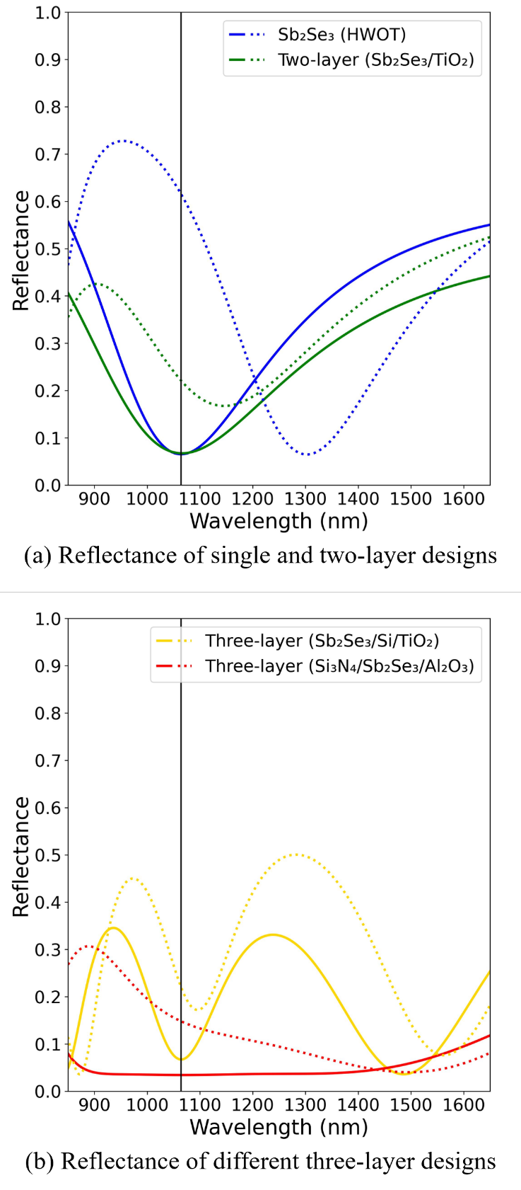
Reflectance of the designs in Fig. 3 before (solid) and after (dotted) phase transition. The single-layer design has the highest reflectance contrast (ΔR = R_{a} – R_{c}) of 55.0%.

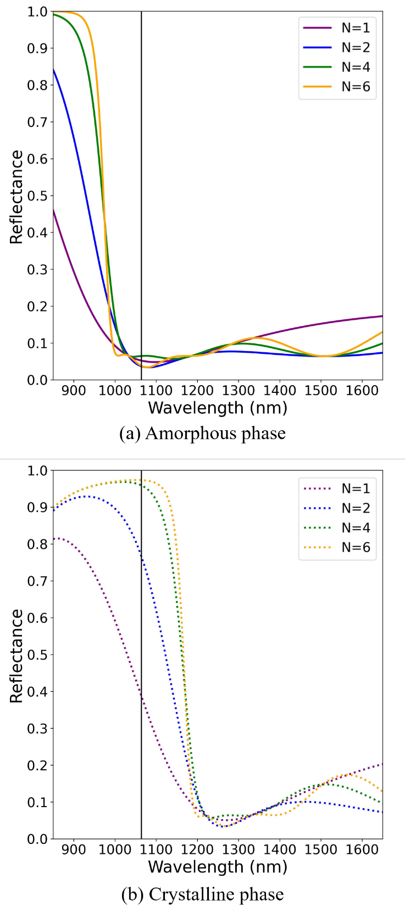
Reflectance profile of long-pass edge-filter designs in each phases. The design used increasing number of unit cell, from 1–6 unit cells. (a) When devices are in amorphous phase (ON mode), the wavelength of interest (black vertical line) is in the AR region. (b) When devices are changed to crystalline phase (OFF mode), the wavelength of interest is in the high-reflection region.
- METHODS
- SIMULATION OF OPTICAL PERFORMANCES
We use transfer matrix method (TMM) of Fresnel equation to calculate the transmittance, absorptance, and reflectance of each design. The computation codes are based on [26], but other simulation software are also applicable. The simulations are going to be from 850–1650 nm at an interval of every 1 nm. The dataset of most element in this work can be found in the website refractiveindex.info [30], with the only exception being Sb₂Se₃ [19]. The high-index layers (H) are silicon with refractive index at 1064 nm equal to n_{Si} = 3.56 [28], titanium dioxide (n_{TiO2} = 2.31) [27], and silicon nitride (n_{Si3N4} = 2.00) [29], while the low-index layers (L) are aluminium oxide (n_{Al2O3} = 1.62) [27], silicon dioxide (n_{SiO2} = 1.47) [25], and magnesium fluoride (n_{MgF2} = 1.38) [26]. The substrate layer has the same refractive index as n_{SiO2} and is 3 mm thick, reflection from the substrate-air layer on the backside is calculated. Every dataset used here has a measuring points from 350–1650 nm at an interval of ≤ 4 nm. And the incident angle is 0°, and light polarization mode is transverse electric (TE), unless specifically mentioned.
The main performance indicators are going to be transmittance at 1064 nm in both phases and the transmittance contrast (ΔT = T_{ON} – T_{OFF}). The secondary performance indicators are; the high-contrast region spectral width, the performance at different polarization and incident angle, the total PCM used, design thickness, and the complexity of the design which is indicated by the number of layers and the number of material types used.
- SIMULATION OF OPTICAL ENDURANCE AND STABILITY UNDER LARGE PHASE SWITCHING CYCLES
Experimental studies have demonstrated that Sb₂Se₃ can has phase switching cycles with minimal degradation of its optical contrast and maintain a low-loss, reversible modulation in the order of 10⁶ phase switching cycles [23]. Even so, Sb₂Se₃ still exhibits a slight complex refractive index drift due to structural relaxation and cumulative thermal damage. Accounting for these variations is essential for ensuring long-term reliability and precision in high-endurance photonic applications [23, 24]. To account for this, the complex refractive index (ñ) can be rewritten as
${\tilde{n}}_{p}\left(C\right)=n_{p}\left(C\right)+ik_{p}\left(C\right)$, (17)
where C is the number of the phase switching cycle. The real part of the refractive index (n) is described by an exponential relaxation towards a saturated value such that
$n_{p}\left(C\right)=n_{p,∞}-\left(n_{p,∞}-n_{p,0}\right) e^{-α_{p}C}$, (18)
where n_{p,∞} is the asymptotic refractive index after many cycles, n_{p,0} is the refractive index at the first cycle (obtained from ellipsometry or literature data), and α_{p} is the drift coefficient per cycle of phase p [21, 35].
Meanwhile, the imaginary part k can be approximated from a linear growth as
$k_{p}\left(C\right)=k_{p,0}(1+β_{p}C)$, (19)
where k_{p,0} is the initial loss, and β_{p} is the loss growth coefficient. Parameter β_{p} is the relative loss per cycle of phase p [23, 36]. The model from Eq. (19) is adopted in this work, they are consistent with experimental trends and with general PCM endurance theory, providing a practical way to assess contrast degradation and threshold drift of PCM-based devices over large cycles [21, 23, 35, 36].
Optical endurance can be quantified using the following metrics; percentage transmitting contrast degradation (D_{pct}) and insertion loss (IL). Transmittance contrast degradation is defined as the change in transmittance contrast after N cycles:
$D_{pct}(C)=\frac{ΔT(C)-ΔT_{0}}{ΔT_{0}}$, (20)
where ΔT₀ is the transmittance contrast between the amorphous and crystalline phases in the initial cycle C = 0 (ΔT₀ = T_{a}(0) - T_{c}(0)). A negative D_{pct} indicates a decreasing contrast.
The insertion loss (IL) of the device at cycle C compares the high-transmittance amorphous phase after the initial cycle:
${IL}_{dB}\left(C\right)=10 log\left[\frac{T_{a}(C)}{T_{a}(0)}\right]$. (21)
A increasing IL_{dB}(C) indicates increasing loss, which is typically driven by the linear growth of the imaginary index k_{p}(C) and by detuning of the resonance due to drift in n_{p}(C).
- RESULTS & DISCUSSIONS
- OPTICAL PROPERTIES OF 1064-NM OPTICAL FILTERS
The design architectures, number of layers, total thickness of Sb₂Se₃, overall design thickness, transmittance in each mode, and transmittance contrast (ΔT = T_{a} - T_{c}) of each design are shown in Table I. The operating wavelength is 1064 nm, the reference wavelength (λ₀) is 1064 nm for single-, two-, and three-layer designs, but λ₀ = 740 nm for all edge-filter designs. The simulation show that only edge-filter designs with at least three unit-cells (N ≥ 3) have ΔT higher than 50%, with 6-unit-cell design having the highest ΔT of 94.5%. However, while there is only marginal improvement in ΔT when N exceeds 3, the Sb₂Se₃ layer thickness and the overall device thickness increase drastically; for example, ΔT improves by 2% in N = 4 design when compared to N = 3 design, the thickness increases by 33.3%, but when comparing N = 5 to N = 4 designs, ΔT increases by only 0.6%, and the device needs to be 25.0% thicker. It is important to note that increasing unit cell numbers also require more Sb₂Se₃ material, less Sb₂Se₃ used also has the benefit of minimizing the energy required for phase transition.
In edge-filter designs, the transmittance in OFF mode decrease with increasing N until it reaches zero in 6-unit-cell design. This is because, unlike the amorphous phase, crystalline phase Sb₂Se₃ still has a small absorption at 1064 nm (k_{SbSe, cry} = 0.0097), so light is absorbed by each layer until T_{OFF} is reduced to zero. For context, the absorption of crystalline Sb₂Se₃ is still an order of 10² smaller than other PCMs, e.g. GST (k_{GST, cry} = 2.4540) or VO2 (k_{VO2, metallic} = 1.4580). Figure 4.1 shows the transmittance contrast of the single-layer design and edge-filter designs (1 ≤ N ≤ 6). Even though the ΔT at 1064 nm edge filter designs with N ≥ 2 are around the same value, the spectral width of high-contrast region is noticeably wider in higher unit-cell designs. This property should be considered if the filter is intended to be used in a broad spectrum applications.

TABLE I
Designs of Sb₂Se₃-based Optical Filters

Design | Layout | Number of layer | SbSe used (nm) | Device size (nm) | T_{ON}  (%) | T_{OFF}  (%) | ΔT  (%)
Single-layer | Sb₂Se₃ | 1 | 157.9 | 157.9 | 93.5 | 37.2 | 56.3
Two-layers | Sb₂Se₃/TiO₂ | 2 | 78.9 | 194.1 | 93.3 | 76.9 | 16.4
Three-layers | Sb₂Se₃/MgF₂/TiO₂ | 3 | 78.9 | 580.3 | 93.3 | 76.9 | 16.4
Three-layers | Si₃N₄/Sb₂Se₃/Al₂O₃ | 3 | 157.9 | 455.7 | 96.6 | 83.3 | 13.3
Edge filter | $${(\frac{{Sb}_{2}{Se}_{3}}{2}/{MgF}_{2}/\frac{{Sb}_{2}{Se}_{3}}{2})}^{1}$$ | 3 | 48.5 | 182.5 | 94.1 | 54.3 | 39.8
Edge filter | $${(\frac{{Sb}_{2}{Se}_{3}}{2}/{MgF}_{2}/\frac{{Sb}_{2}{Se}_{3}}{2})}^{2}$$ | 5 | 97.0 | 365.0 | 95.0 | 16.3 | 78.7
Edge filter | $${(\frac{{Sb}_{2}{Se}_{3}}{2}/{MgF}_{2}/\frac{{Sb}_{2}{Se}_{3}}{2})}^{3}$$ | 7 | 145.5 | 547.6 | 94.8 | 4.0 | 90.8
Edge filter | $${(\frac{{Sb}_{2}{Se}_{3}}{2}/{MgF}_{2}/\frac{{Sb}_{2}{Se}_{3}}{2})}^{4}$$ | 9 | 194.0 | 730.1 | 93.7 | 0.9 | 92.8
Edge filter | $${(\frac{{Sb}_{2}{Se}_{3}}{2}/{MgF}_{2}/\frac{{Sb}_{2}{Se}_{3}}{2})}^{5}$$ | 11 | 242.6 | 912.6 | 93.6 | 0.2 | 93.4
Edge filter | $${(\frac{{Sb}_{2}{Se}_{3}}{2}/{MgF}_{2}/\frac{{Sb}_{2}{Se}_{3}}{2})}^{6}$$ | 13 | 291.1 | 1,095.1 | 94.5 | 0.0 | 94.5
Transmittance is calculated at λ = 1064 nm. Single, two, and three-layer designs all have λ₀ = 1064 nm, but all edge-filter designs have λ₀ = 740 nm
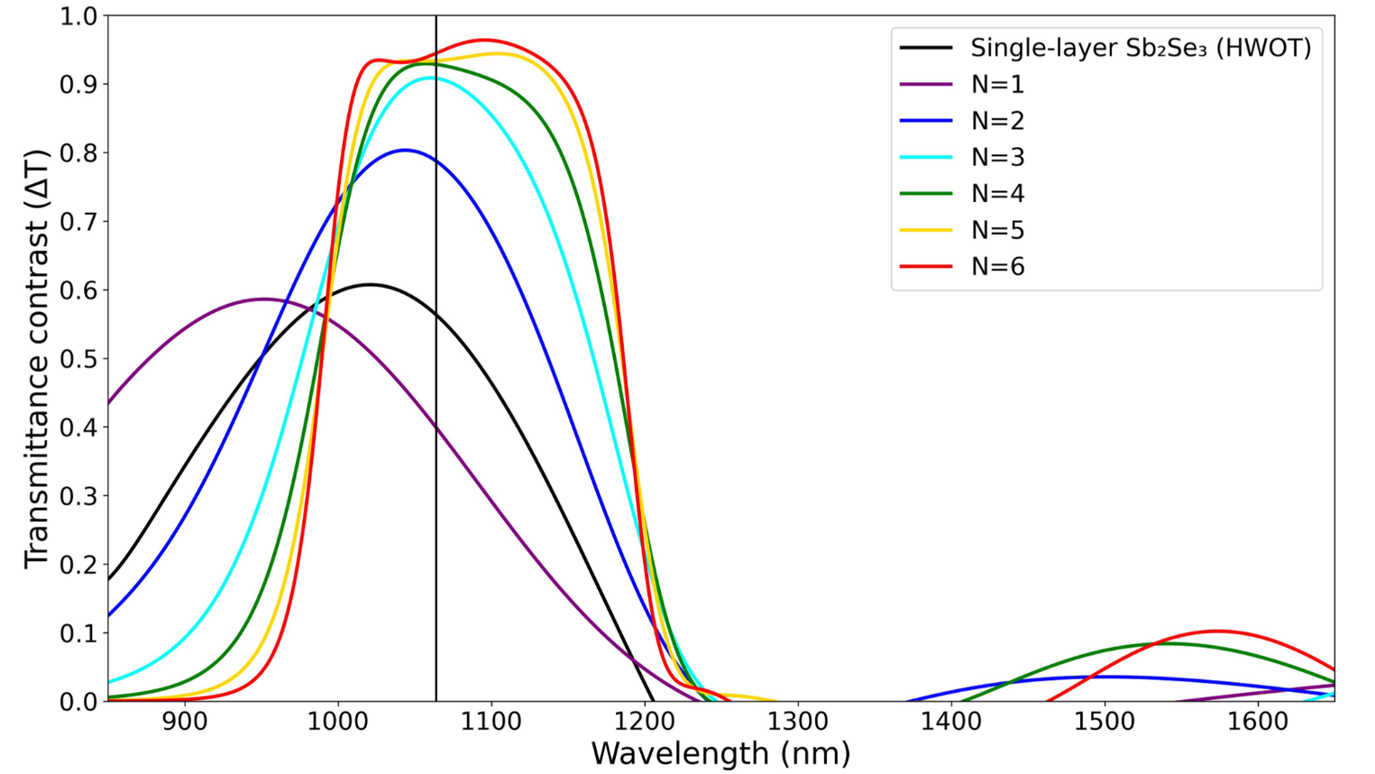
Transmittance contrast (ΔT) of a single-layer and edge-filter designs with different number of unit cells (N). The vertical black line indicates the interested 1064 nm wavelength.

Two other properties that might need to be considered are the optical performance at varying incident angles and the polarization mode of the incident light (TE or TM). Figure 7 shows 4-unit-cell and 5-unit-cell designs with incident angles ranging from 0° to 90°, and with polarization in TE (Fig. 7a and 7c) and TM (Fig. 7b and 7d). For both TE and TM polarized light, ΔT remains higher than 90% from 0° to ~30°, but TM polarization causes the high-ΔT region to blueshift significantly at higher incident angle. The spectral widths of the high-ΔT region in both designs are comparable, but the 5-unit-cell design has a higher ΔT across the spectrum, which indicates a better broadband, wide-angle, tunable optical device.
With the reasons given above, we decided that a 5-unit-cell, long-pass edge-filter design (Fig. 6, yellow) has the best compromise between high optical performances, device size, and complexity. This design has a broadband transmittance contrast between the amorphous (ON mode) and the crystalline phases (OFF mode), and the FWHM of high-ΔT region is 197.0 nm. This design is used as an example in the following sections.
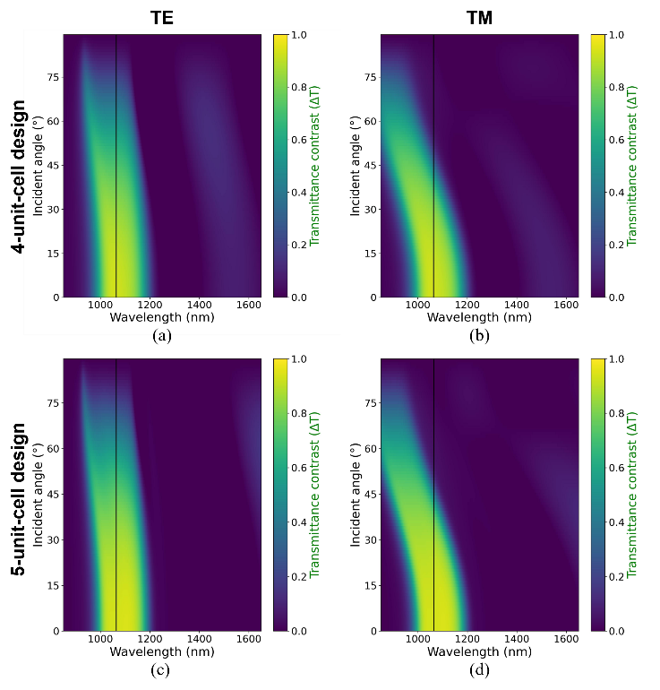
Transmittance contrast at different incident angles and wavelengths of 4-unit-cell and 5-unit-cell long-pass edge-filter designs.
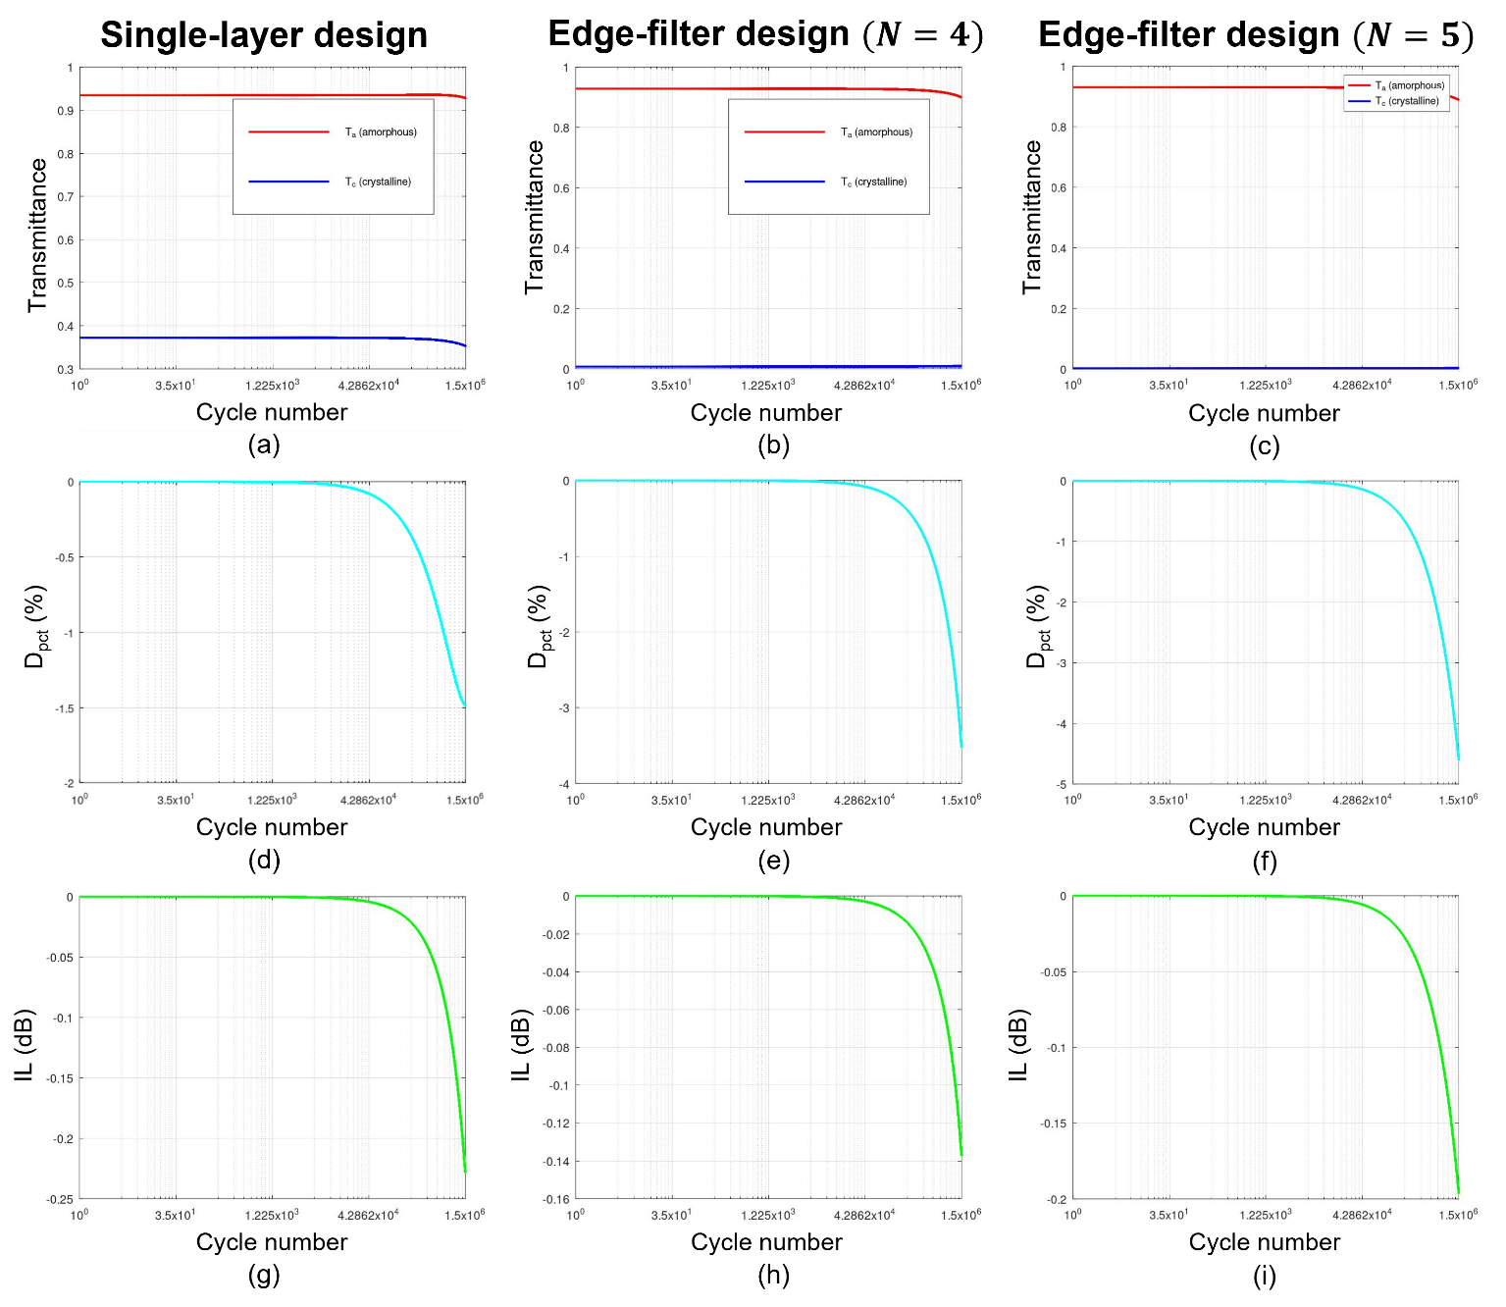
Optical endurance at 1064 nm of the single-layer, and 5-unit-cell edge-filter designs after 1.5×10⁶ phase-switching cycles. (a,b,c) Transmittance in amorphous (red) and crystalline phases (blue). (d,e,f) The percentage transmittance contrast degradation relative to the initial value. (g,h,i) Insertion loss in amorphous phase, expressed in dB. Note a different y-axis scales.

ENDURANCE SIMULATION OF 1064-nm OPTICAL FILTERS
Endurance simulation at 1064 nm of the single-layer Sb₂Se₃, and 5-unit-cell edge-filter designs demonstrated that all three resonant optical filters remain operational up to 1.5×10⁶ phase switching cycles, with design-dependent degradation of their transmittance metrics. For the single-layer design, both the amorphous (T_{a}) and crystalline phases transmittance (T_{c}) decrease modestly (Fig. 8a). And both the corresponding percentage transmittance contrast degradation (D_{pct}) and insertion loss (IL) also decrease with cycling number, as shown in Fig. 8d and 8g, respectively.
For both the 4- and 5-unit-cell edge-filter designs, the T_{a} and insertion loss decrease at a rate slower than in the single layer design, and their T_{c} increased slightly near the end. This causes their percentage transmittance contrast degradation to become two and three times larger, Fig. 8e and 8f, respectively. Their larger D_{pct} are attributed to the fact that their T_{c} become higher at the latter cycle. Edge-filter designs have a stronger field confinement so they exhibit less insertion losses when compared to the single-layer design.
These simulation results confirm that designs with multiple layers of Sb₂Se₃ still maintains comparable transmittance endurance to a simple, single-layer design. Their larger D_{pct} might become a problem at larger switching cycle but is overall negligible in the confine of our simulation. Overall, the edge-filter designs still have a higher transmittance contrast and a lower insertion loss after 1.5×10⁶ cycles.

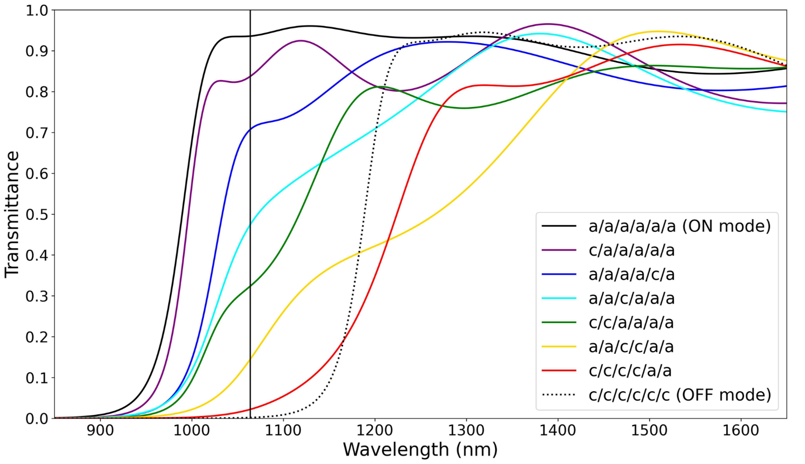
Transmittance of the five-unit-cell edge-filter design in 8 different configurations. Each Sb₂Se₃ layer is in amorphous (a) or crystalline (c) phases, and the layout ordering from left to right is substrate-side to air-side.

TRANSMITTANCE TUNABILITY AND OPTIMIZATION
Edge-filter designs have multiple layers of Sb₂Se₃ which complicates the phase switching setup. When laser-induced heating is used as a switching method, the phase transition of every Sb₂Se₃ layer does not occur simultaneously and the transmission changes gradually. This effect is shown in the optical limiter of Sarangan, et al. [3] Their device use a similar long-pass edge-filter design but the H layers are GST instead of Sb₂Se₃, and the L layers are SiO₂ instead of MgF₂. Their experimental results showed that the phase switching of GST layers occurs layer-by-layer in an order that is determined by the changes in the optical field distribution and thermal crosstalk between layers, which does not necessarily start from layer in the air -side to the substrate-side (top to bottom). However, our device is intended to be used as a transmittance-tunable filter that does not require a fast switching speed; therefore, electrical heating is also available as an alternative phase switching method. The ability to manually control the phase of each Sb₂Se₃ layer enables the filter to have multiple transmittance values. Using the 5-unit-cell edge-filter design described in Table I, which consists of 11 layers of Sb₂Se₃ and MgF₂ (six layers of Sb₂Se₃), there would be a total of 2⁶ configurations for the Sb₂Se₃ phases. Figure 9 highlights some of these configurations; the legend denotes Sb₂Se₃ in the amorphous (a) or crystalline phase (c), and the ordering from left to right is from the substrate to the air side (f₁ to f₆). With the correct phase configuration, the transmittance can be gradually reduced from peak of 93.4% to 0.0%.
The peak transmittance contrast of each design shown in Fig. 6 does not always correspond to the desired operating wavelength of 1064 nm. This is explained by the arbitrary selection of the reference wavelength in edge-filter designs. So, an optimization algorithm can be used to improve the optical performance. A simple merit function found in OpenFilters [33] is used in this example. The optimization goal for the 5-unit-cell edge-filter design is to have a transmittance value of at least 97% from 1000 to 1200 nm at intervals of every 20 nm. The optimization took less than 5 s, and the new design now required 304.2 nm of Sb₂Se₃, 25% more than the original design, but the overall thickness is now 845.6 nm, 7% less than the original, the thickness of each layer is shown in Table II. Figure 10a shows the transmittance of the original (green) and optimized designs (blue) in the amorphous (solid) and crystalline phases (dotted). Overall, the optimized design has a higher transmittance in the desired 1000 to 1200 nm spectrum, but the spectral profile has been blue shifted by a small amount. The transmittance contrast at 1064 nm (Fig. 10b) of the optimized design is also higher, 95.8%, compared to 93.4% of the original. The transmittance contrast FWHM also extended slightly to 207.4 nm (original: 197.0 nm)
TABLE II
Thickness of Each Layer Before and After Optimization

Design | SiO₂ | Sb₂Se₃ | MgF₂ | Sb₂Se₃ | MgF₂ | Sb₂Se₃ | MgF₂ | Sb₂Se₃ | MgF₂ | Sb₂Se₃ | MgF₂ | Sb₂Se₃
Original | 3 mm | 24.3 | 134.0 | 48.5 | 134.0 | 48.5 | 134.0 | 48.5 | 134.0 | 48.5 | 134.0 | 24.3
Optimized | 3 mm | 46.1 | 67.5 | 59.3 | 148.1 | 55.0 | 89.3 | 50.0 | 145.3 | 63.3 | 91.2 | 30.5
Original design is the 5-unit-cell long-pass edge filter. The units of Sb₂Se₃ and MgF₂ thickness are nm.

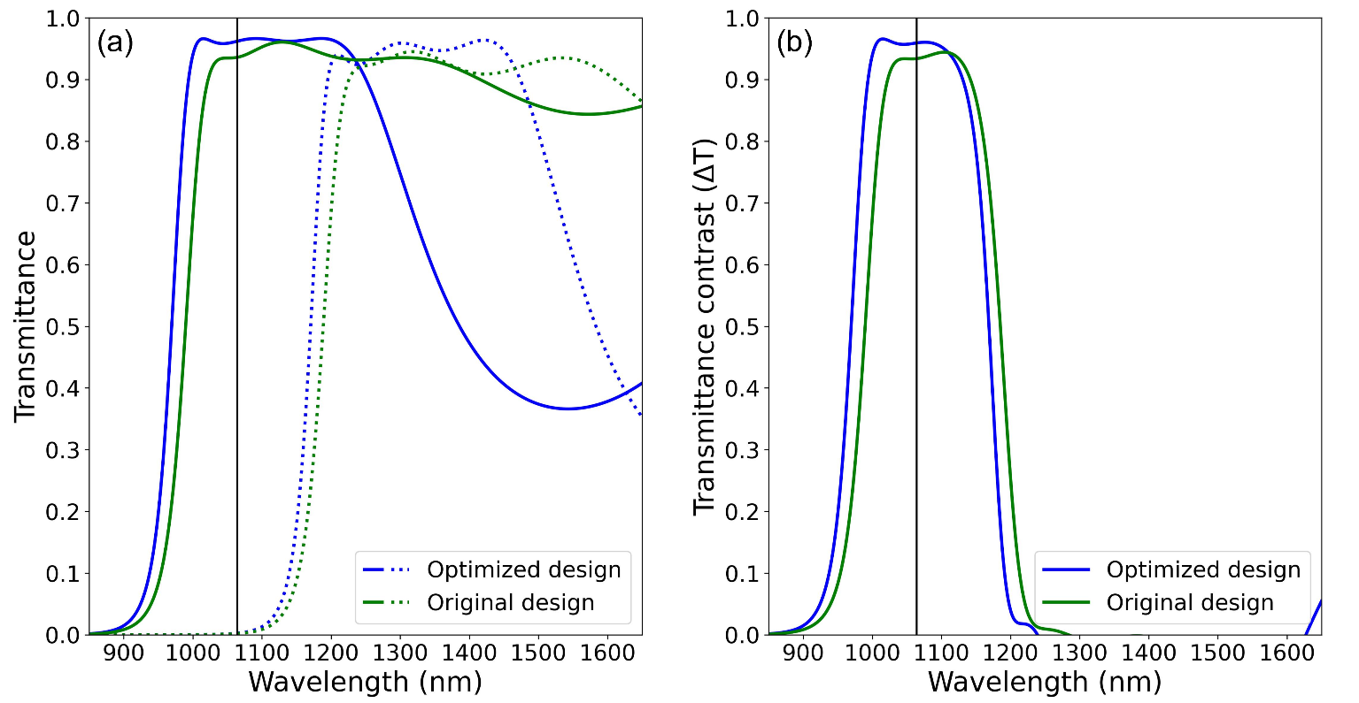
- Transmittance comparison of 5-unit-cell edge-filter design before (green) and after (blue) optimization. (a) The transmittance in ON mode (solid) and OFF mode (dotted). (b) The transmittance contrast (ΔT). An optimized design has higher optical performance from 900 to 1200 nm, but the high- ΔT region has been blueshifted by a small amount.

- Conclusions
We have shown that Sb₂Se₃ is a suitable PCM for high-efficient, broadband transmittance-tunable optical filter operating around 1064 nm wavelength. The 5-unit-cell long-pass edge-filter design has the best compromise between optical performance, size, and design complexity. This design required six Sb₂Se₃ layers and five MgF₂ layers and is 912 nm thick. Transmittance at 1064 nm in the ON mode is 93.4% and 0.2% in OFF mode, a contrast of 93.4% with around 200 nm FWHM. Simulations show that after 1.5×10⁶ phase switching cycles, the transmittance contrast degradation and insertion loss in ON mode is still within acceptable ranges. The multilayer nature of edge-filter design enables the gradual modulation of transmittance by changing the phase of each Sb₂Se₃ layer. We also show that a quick and simple optimization algorithm can increase the optical performance from 900-1200 nm.

ACKNOWLEDGMENT
The authors greatly appreciate the discussion, grammatical and format suggestions from Nathan Hagen, Center for Optical Research and Education, Utsunomiya University, Japan.
DISCLOSURE
The authors declare no competing interests.
DATA AVAILABILITY
Data underlying the results presented in this paper may be obtained from the corresponding author upon a reasonable request.
DECLARATION OF AI USAGE
Gemini was used for code debugging and grammar correction. Consensus was used to help with the initial literature review. The authors have reviewed and edited the content as needed after using these tools.
References
[1] K. Matuszek, M. Kar, J. M. Pringle, and D. R. MacFarlane, "Phase Change Materials for Renewable Energy Storage at Intermediate Temperatures," Chemical Reviews, vol. 123, no. 1, pp. 491–514, 2023/01/11 2023, doi: 10.1021/acs.chemrev.2c00407.
[2] R. Matos and N. Pala, "A Review of Phase-Change Materials and Their Potential for Reconfigurable Intelligent Surfaces," Micromachines, vol. 14, no. 6, p. 1259, 2023. [Online]. Available: https://www.mdpi.com/2072-666X/14/6/1259.
[3] A. Sarangan, J. Duran, V. Vasilyev, N. Limberopoulos, I. Vitebskiy, and I. Anisimov, "Broadband Reflective Optical Limiter Using GST Phase Change Material," IEEE Photonics Journal, vol. 10, no. 2, pp. 1–9, 2018, doi: 10.1109/jphot.2018.2796448.
[4] K. Aryana et al., "Optical and thermal properties of Ge2Sb2Te5, Sb2Se3, and Sb2S3 for reconfigurable photonic devices [Invited]," Opt. Mater. Express, vol. 13, no. 11, 2023, doi: 10.1364/ome.503178.
[5] W. Jia, R. Menon, and B. Sensale-Rodriguez, "Unique prospects of phase change material Sb2Se3 for ultra-compact reconfigurable nanophotonic devices," Opt. Mater. Express, vol. 11, no. 9, pp. 3007–3014, 2021/09/01 2021, doi: 10.1364/OME.435979.
[6] S. Blundell et al., "Ultracompact Programmable Silicon Photonics Using Layers of Low-Loss Phase-Change Material Sb2Se3 of Increasing Thickness," ACS Photonics, vol. 12, no. 3, pp. 1382–1391, 2025/03/19 2025, doi: 10.1021/acsphotonics.4c01789.
[7] C. Wan et al., "Ultrathin Broadband Reflective Optical Limiter," Laser & Photonics Reviews, vol. 15, no. 6, p. 2100001, 2021, doi: https://doi.org/10.1002/lpor.202100001.
[8] X. Ling, X. Pang, X. Chen, and Z. Shao, "Broadband mid-infrared optical limiter based on&#x00A0;vanadium dioxide phase transition," J. Opt. Soc. Am. B, vol. 42, no. 9, pp. 2062–2067, 2025/09/01 2025, doi: 10.1364/JOSAB.569492.
[9] M. Gandolfi et al., "Optical Limiting Thin Multilayer Films Based On Phase Transition In VO2," in 2022 Sixteenth International Congress on Artificial Materials for Novel Wave Phenomena (Metamaterials), 12–17 Sept. 2022 2022, pp. 148–150, doi: 10.1109/Metamaterials54993.2022.9920767. [Online]. Available: https://ieeexplore.ieee.org/stampPDF/getPDF.jsp?tp=&arnumber=9920767&ref=
[10] A. Tognazzi et al., "Opto-thermal dynamics of thin-film optical limiters based on the VO2 phase transition," Opt. Mater. Express, vol. 13, no. 1, pp. 41–52, 2023/01/01 2023, doi: 10.1364/OME.472347.
[11] Y. Li et al., "An Adaptive Optical Limiter Based on a VO2/GaN Thin Film for Infrared Lasers," Photonics, vol. 13, no. 2, p. 148, 2026. [Online]. Available: https://www.mdpi.com/2304-6732/13/2/148.
[12] Y. Zhang et al., "Broadband transparent optical phase change materials for high-performance nonvolatile photonics," Nature Communications, vol. 10, no. 1, p. 4279, 2019/09/30 2019, doi: 10.1038/s41467-019-12196-4.
[13] H. Li, D. Zeng, Y. Huang, Q. Huang, and X. Zhang, "Ultra-compact, ultra-low-loss and broadband 2 x 2 nonvolatile optical switch based on Sb(2)Se(3) phase change material," Opt Express, vol. 32, no. 20, pp. 35287–35297, Sep 23 2024, doi: 10.1364/OE.534645.
[14] R. Heenkenda, K. Hirakawa, and A. Sarangan, "Tunable optical filter using phase change materials for smart IR night vision applications," Opt. Express, vol. 29, no. 21, pp. 33795–33803, 2021/10/11 2021, doi: 10.1364/OE.440299.
[15] Y.-S. Huang et al., "Tunable structural transmissive color in fano-resonant optical coatings employing phase-change materials," Materials Today Advances, vol. 18, p. 100364, 2023/06/01/ 2023, doi: https://doi.org/10.1016/j.mtadv.2023.100364.
[16] M. Cui et al., "Tunable multi-channel optical filter based on the near-infrared ultralow-loss phase change material Sb2Se3," Opt. Express, vol. 34, no. 5, pp. 7378–7387, 2026/03/09 2026, doi: 10.1364/OE.586098.
[17] R. Patel, N. Patel, N. Bazzanella, and A. Miotello, "Fabricating multilayer antireflective coating for near complete transmittance in broadband visible light spectrum," Optical Materials, vol. 108, p. 110415, 2020/10/01/ 2020, doi: https://doi.org/10.1016/j.optmat.2020.110415.
[18] X. Tian and Z.-Y. Li, "An Optically-Triggered Switchable Mid-Infrared Perfect Absorber Based on Phase-Change Material of Vanadium Dioxide," Plasmonics, vol. 13, no. 4, pp. 1393–1402, 2018/08/01 2018, doi: 10.1007/s11468-017-0643-9.
[19] C. Liu et al., "Tunable nonlinear optical absorption in amorphous and crystalline Sb2Se3 thin films," Journal of Alloys and Compounds, vol. 791, pp. 753–760, 2019/06/30/ 2019, doi: 10.1016/j.jallcom.2019.03.295.
[20] I. O. Oguntoye, S. Padmanabha, M. Hinkle, T. Koutsougeras, A. J. Ollanik, and M. D. Escarra, "Continuously Tunable Optical Modulation Using Vanadium Dioxide Huygens Metasurfaces," ACS Applied Materials & Interfaces, vol. 15, no. 34, pp. 41141–41150, 2023/08/30 2023, doi: 10.1021/acsami.3c08493.
[21] M. Delaney, I. Zeimpekis, D. Lawson, D. W. Hewak, and O. L. Muskens, "A New Family of Ultralow Loss Reversible Phase‐Change Materials for Photonic Integrated Circuits: Sb2S3 and Sb2Se3," Advanced Functional Materials, vol. 30, no. 36, 2020, doi: 10.1002/adfm.202002447.
[22] A. A. Burtsev et al., "Physical properties’ temperature dynamics of GeTe, Ge2Sb2Te5 and Ge2Sb2Se4Te1 phase change materials," Materials Science in Semiconductor Processing, vol. 150, p. 106907, 2022/11/01/ 2022, doi: https://doi.org/10.1016/j.mssp.2022.106907.
[23] D. Lawson, S. Blundell, M. Ebert, O. L. Muskens, and I. Zeimpekis, "Optical switching beyond a million cycles of low-loss phase change material Sb2Se3," Opt. Mater. Express, vol. 14, no. 1, 2023, doi: 10.1364/ome.509434.
[24] M. S. Alam et al., "Fast Cycling Speed with Multimillion Cycling Endurance of Ultra-Low Loss Phase Change Material (Sb2Se3) by Engineered Laser Pulse Irradiation," Advanced Functional Materials, vol. 34, no. 14, p. 2310306, 2024, doi: https://doi.org/10.1002/adfm.202310306.
[25] X. Chen, J. Lin, and K. Wang, "A Review of Integrated Photonic Devices Using Sb2Se3," Advanced Physics Research, vol. 4, no. 1, p. 2400080, 2024, doi: 10.1002/apxr.202400080.
[26] A. Sarangan, Optical Thin Film Design, 1st Edition ed. Boca Raton: CRC Press, 2020.
[27] D. Franta, D. Nečas, I. Ohlídal, and A. Giglia, Optical characterization of SiO2 thin films using universal dispersion model over wide spectral range (SPIE Photonics Europe). SPIE, 2016.
[28] D. Franta, D. Nečas, A. Giglia, P. Franta, and I. Ohlídal, "Universal dispersion model for characterization of optical thin films over wide spectral range: Application to magnesium fluoride," Applied Surface Science, vol. 421, pp. 424–429, 2017/11/01/ 2017, doi: https://doi.org/10.1016/j.apsusc.2016.09.149.
[29] S. V. Zhukovsky et al., "Experimental Demonstration of Effective Medium Approximation Breakdown in Deeply Subwavelength All-Dielectric Multilayers," Physical Review Letters, vol. 115, no. 17, p. 177402, 10/23/ 2015, doi: 10.1103/PhysRevLett.115.177402.
[30] Y. Li et al., "Preparation of mechanically stable triple-layer interference broadband antireflective coatings with self-cleaning property by sol–gel technique," RSC Advances, 10.1039/C7RA00844A vol. 7, no. 24, pp. 14660–14668, 2017, doi: 10.1039/C7RA00844A.
[31] D. Franta, P. Franta, J. Vohánka, M. Čermák, and I. Ohlídal, "Determination of thicknesses and temperatures of crystalline silicon wafers from optical measurements in the far infrared region," Journal of Applied Physics, vol. 123, no. 18, 2018, doi: 10.1063/1.5026195.
[32] L. Y. Beliaev, E. Shkondin, A. V. Lavrinenko, and O. Takayama, "Optical, structural and composition properties of silicon nitride films deposited by reactive radio-frequency sputtering, low pressure and plasma-enhanced chemical vapor deposition," Thin Solid Films, vol. 763, p. 139568, 2022/12/01/ 2022, doi: https://doi.org/10.1016/j.tsf.2022.139568.
[33] S. Larouche and L. Martinu, "OpenFilters: open-source software for the design, optimization, and synthesis of optical filters," Appl. Opt., vol. 47, no. 13, pp. C219–C230, 2008/05/01 2008, doi: 10.1364/AO.47.00C219.
[34] M. N. Polyanskiy, "Refractiveindex.info database of optical constants," Scientific Data, vol. 11, no. 1, p. 94, 2024/01/18 2024, doi: 10.1038/s41597-023-02898-2.
[35] L. Martin-Monier et al., "Endurance of chalcogenide optical phase change materials: a review," Opt. Mater. Express, vol. 12, no. 6, pp. 2145–2167, 2022/06/01 2022, doi: 10.1364/OME.456428.
[36] Y. Zhang et al., "Myths and truths about optical phase change materials: A perspective," Applied Physics Letters, vol. 118, no. 21, 2021, doi: 10.1063/5.0054114.


CHETTANAT PADUNGATTHAKIJ received the B.Sc. degree in applied physics from King Mongkut’s Institute of Technology Ladkrabang, Thailand, in 2025, where he is currently pursuing the M.Sc. degree. His current research interests are optical thin film design from phase change material and neural network-based optical coherence tomography image generation.


PRATHAN BURANASIRI received the B.Sc. degree in physics from Ramkhamhaeng University, Thailand in 1993. He then received the M.Sc. in physics and Ph.D. degree in electrical engineering from The University of Alabama in Huntsville and University of Dayton, in 2000 and 2006, respectively.
Currently, he is an assistant professor at the Department of Physics of King Mongkut’s Institute of Technology Ladkrabang, Bangkok, Thailand. His recent research interests include nanophotonics, photorefractive materials, metamaterials, phase change materials, and digital holography.


SUEBTARKUL SUCHAT received the B.Sc. degree in physics from Ramkhamhaeng University, Bangkok, Thailand in 1993. He then received the M.Sc. and Ph.D. degrees in applied physics from King Mongkut’s Institute of Technology Ladkrabang, Bangkok, Thailand, in 1999 and 2007, respectively.
He is current an associate professor at Department of Applied Physics, Phranakhon Rajabhat University, Bangkok, Thailand. His research interests are quantum optics, optical sensors, and material sciences.


SURAWUT WICHARN (member, IEEE) received the B.Sc. with honor class, M.Sc., and Ph.D. degrees in applied physics from King Mongkut’s Institute of Technology Ladkrabang, Bangkok, Thailand, in 2007, 2010, and 2014, respectively.
Currently, he is an assistant professor at the Department of Physics of Srinakharinwirot University, Bangkok, Thailand. His research areas have included nanophotonics, metamaterials, and computational electromagnetics.

